**PHONE BOOK**

**\*This project will help user to find a contact and t the data of this contact between a number of contacts :**

**1-Name**

**2-Lastname**

**3-Date of birthe (day-month-year)**

**4-Address**

**5-Email**

**6-Phone number**

**\*Also the could have many options to use in this project :**

**1- To search the contact that he wants**

**2-To add to this phone book a new number**

**3-To delete the contact that he dosen’t want anymore.**

**4-To modify the data of a contact**

**5-To print the data of the contact sorted by the way he hants either by date of birth or by the name or lastname**

**This is some photos for the way how the project works:**

**1-while running the program this screen will appear ,where we can see the menu which contains all the options :**

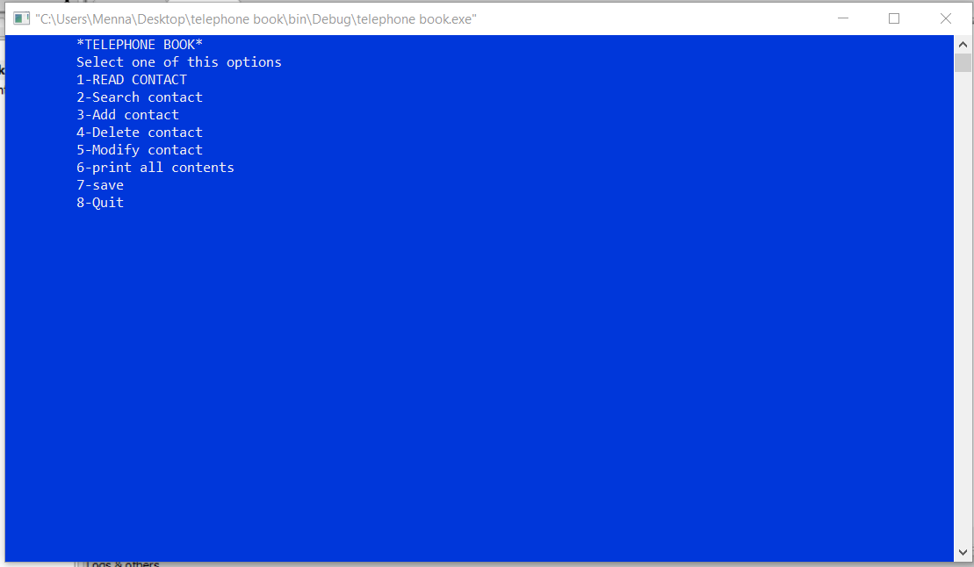

**2-choosing 1 will help the user to load the information but the informations will never appear on the screen unless he chooses print contacts as we will show.**

**3-when we want to search a contact we choose the fist option by entering 2 and he can the search the contact by lastname**

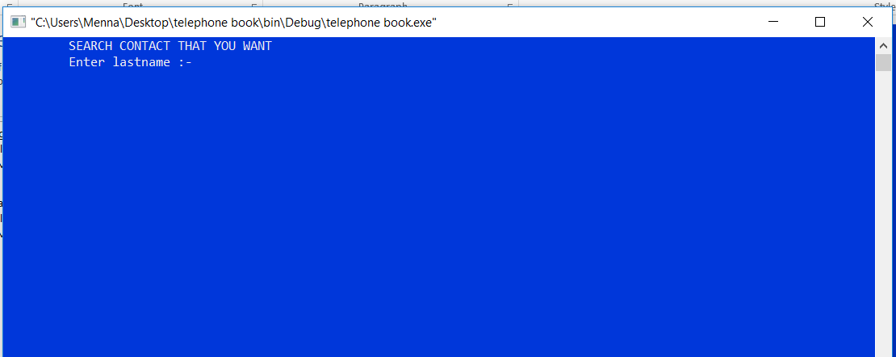**4-adding a contact will be by choosing number3:** 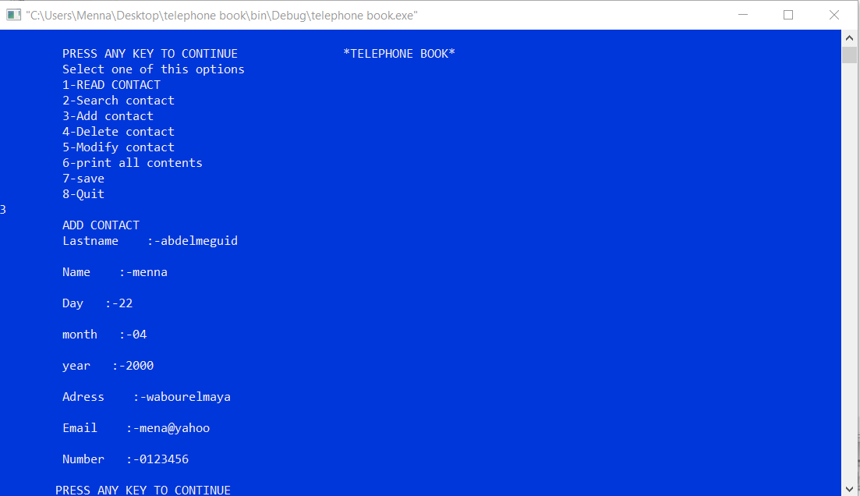

**5-Deleting a contact will be by choosing number 4 then entering the file name where the informations are written then entering the number of the line that we want to delete .**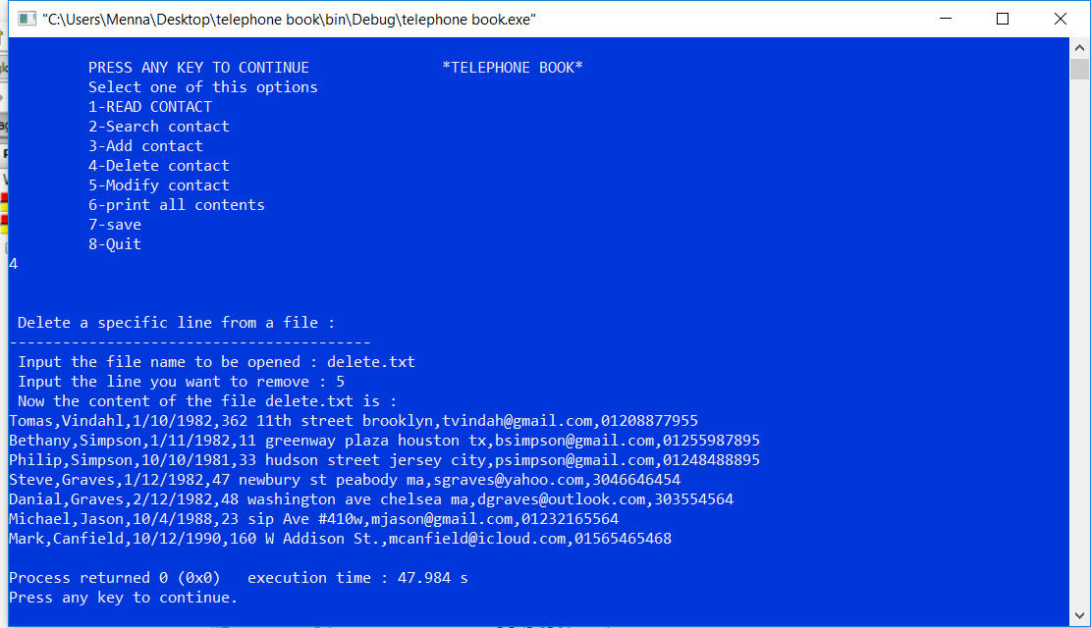

**6-To modify a contact we choose number 5 so we can enter the new data of the contact:** 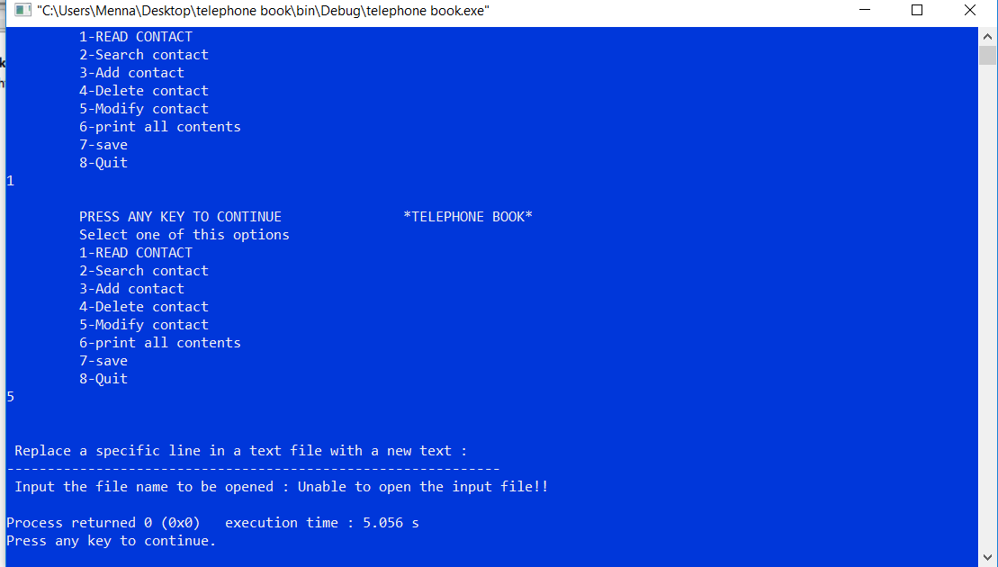

**7-when we choose print the informations of contacts will appear on the screen but first we should choose how they should be sorted by name or by the date of birth:**

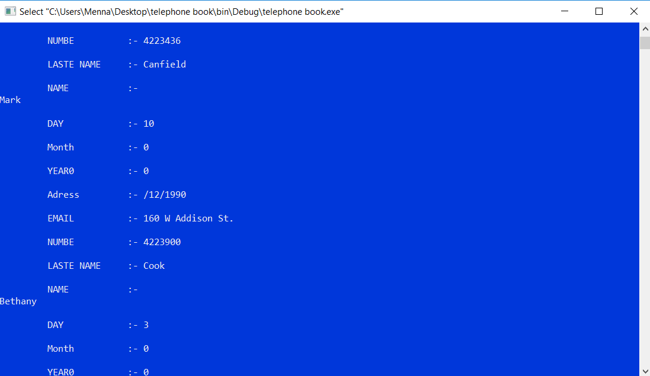

**6-saving the editing of the the phone book will be by choosing number 7** 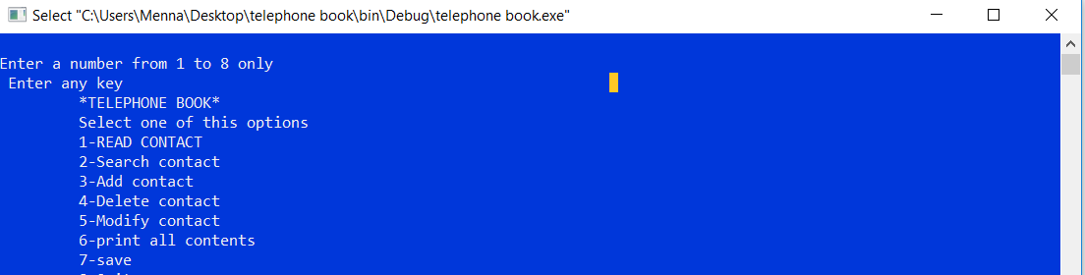

**7-to exit the phone book we choose 8**

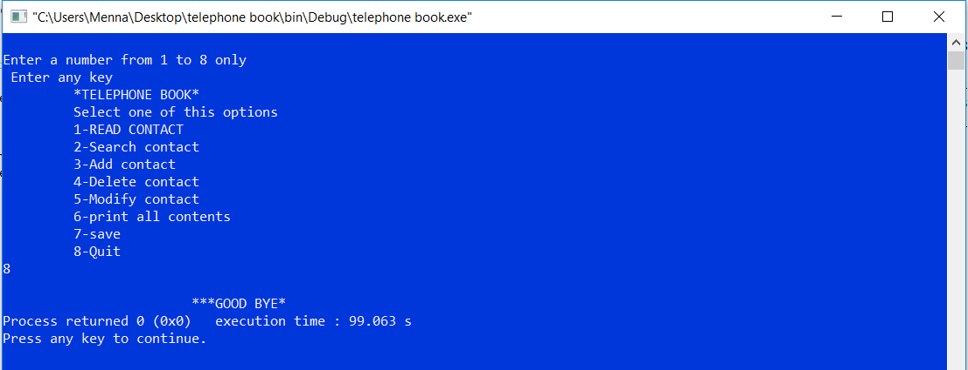

**How it works**

1-we have made a structure for contacts containing the data of this contacts:

**typedef struct**

**{**

**char lastname[50];**

**char name[100];**

**int day;**

**int month;**

**int year;**

**char adress[100];**

**char email[100];**

**char number[100];**

**} contact;**

2-we have made 7 functions each function of them have have is used to make a special work as we had explained in the user manual:

void load();

void add_contact();

void search_contact();

void delet_contacts();

void modify_contact();

void sortdob();

void sort();

void print_contacts();

void save();

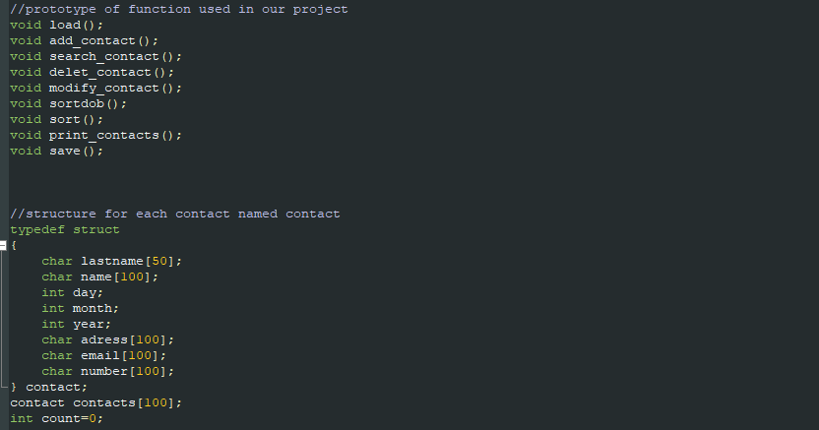



Names:

1-menna abdel meguid abdelsalam

Id:6538

Group 1

Section 2

2-amr mahdy

Id:6270

Group 1

Section 2

3-injy elsakhawy

Id:6477

Group 2

Secation 2